**Exercise 1: Configuring a Basic Spring Application**

**Scenario:**

Your company is developing a web application for managing a library. You need to use the Spring Framework to handle the backend operations.

**SOLUTION:**

**pom.xml**

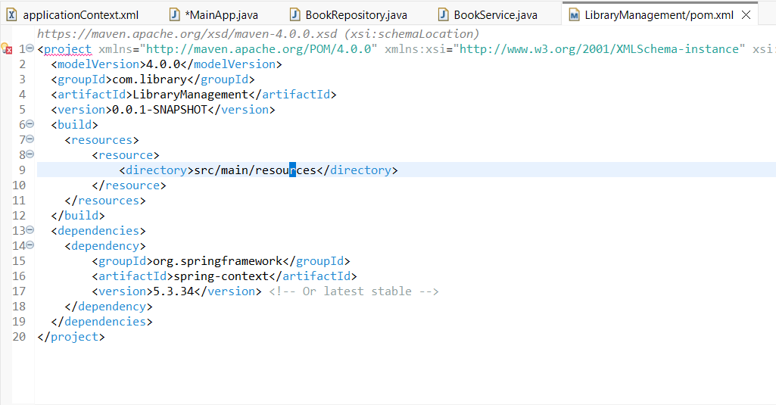

**applicationContext.xml**

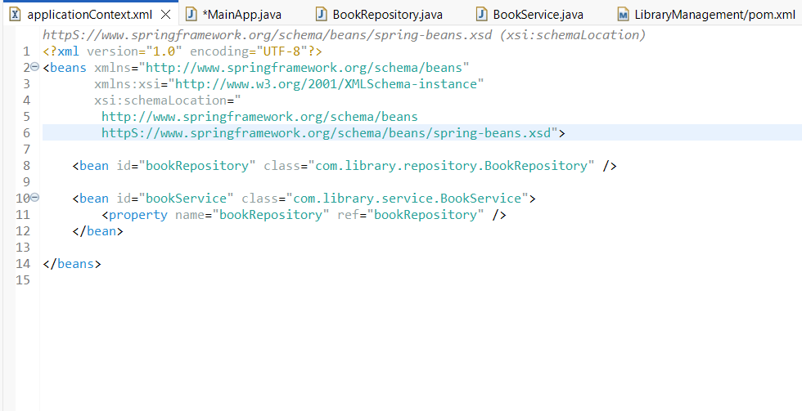

**BookRepository.java**

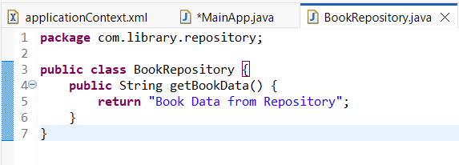

**BookService.java**

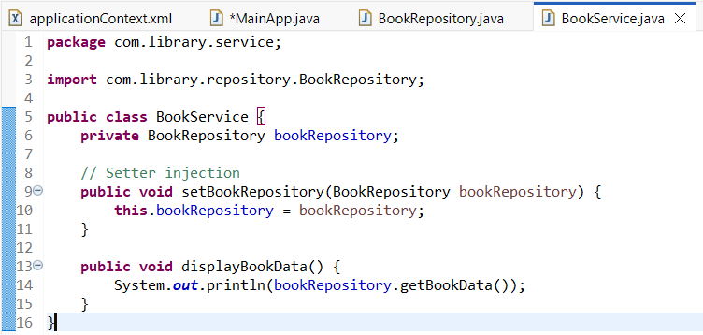

**OUTPUT**

